**CAD_PHASE 2**

**INNOVATION**

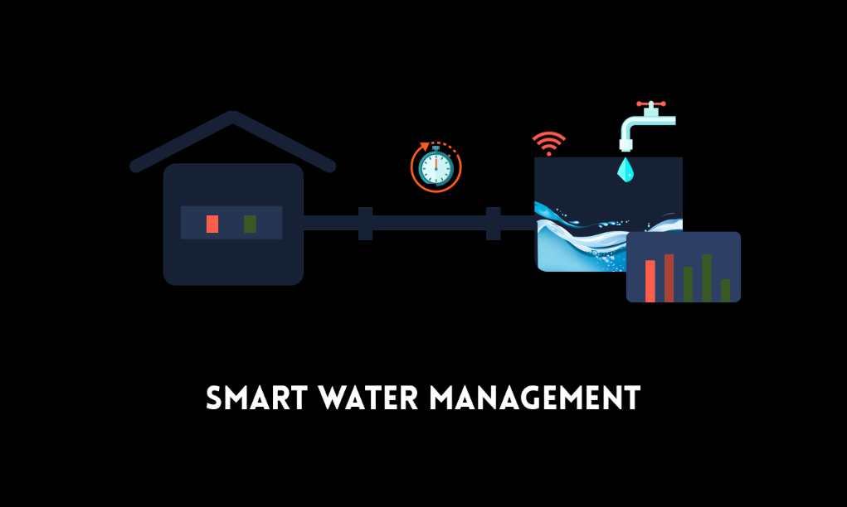**Innovative machine learning algorithms can significantly enhance the capabilities of smart water systems, enabling efficient water distribution, conservation, and management. Here are some innovative machine learning algorithms tailored for smart water systems:**

1. **Deep Reinforcement Learning for Water Resource Allocation:**

- Apply deep reinforcement learning algorithms to optimize the allocation of water resources in a smart water grid. These algorithms can learn to make real-time decisions on when and how much water to allocate to different areas or users, considering factors like demand, supply, and infrastructure conditions.

**2.** **Predictive Analytics for Water Quality Monitoring:**

- Develop predictive models using machine learning to forecast water quality changes. These models can alert water treatment facilities to potential contamination events or changes in water quality, allowing for timely intervention.

**3. Real-time Leak Detection with Anomaly Detection:**

- Implement advanced anomaly detection algorithms, such as Recurrent Neural Networks (RNNs) or Long Short-Term Memory (LSTM) networks, to identify abnormal patterns in water flow or pressure data. These anomalies may indicate leaks, bursts, or other pipeline issues in real-time.

4. **Data Fusion for Multi-Sensor Integration:**

- Combine data from various sensors, including flow meters, pressure sensors, and water quality sensors, using data fusion techniques to obtain a comprehensive view of the water distribution system's performance and condition.

**5. Energy-Efficient Pumping Optimization:**

- Utilize machine learning algorithms to optimize the operation of pumps and valves in water distribution networks. These algorithms can dynamically adjust pump speeds and valve positions to minimize energy consumption while meeting water demand.

**6. Demand Forecasting with Time Series Analysis:**

- Apply time series forecasting techniques, such as ARIMA or Prophet, to predict future water demand patterns accurately. This information can be used for proactive resource allocation and efficient water distribution.

**7. Hydraulic Modeling and Simulation:**

- Develop machine learning models that simulate the hydraulic behavior of the water distribution network. These models can help in predicting how changes in the system will affect water flow and pressure, enabling better system planning and management.

**8. Smart Irrigation Systems:**

- Implement machine learning algorithms in smart irrigation systems to optimize watering schedules for agricultural and landscape irrigation based on weather forecasts, soil moisture levels, and plant type.

**9. Real-time Water Quality Monitoring with Sensors and IoT:**

- Combine IoT sensors with machine learning algorithms to detect and respond to water quality deviations in real-time. Machine learning models can process sensor data and trigger actions when specific thresholds are crossed.

**10. Distributed Sensor Networks for Early Warning:**

- Deploy distributed sensor networks throughout the water distribution system to provide early warnings for potential issues like contamination, leaks, or equipment failures.

**11. Energy Harvesting and Optimization:**

- Develop algorithms that optimize the use of renewable energy sources (e.g., solar or wind) for powering water treatment and distribution facilities, improving sustainability.

**12. Blockchain for Water Management and Billing:**

- Implement blockchain technology for transparent and secure management of water transactions, including billing, meter reading, and water trading in a smart water grid.

**13. Explainable AI (XAI) for Decision Support:**

- Utilize explainable AI techniques to provide clear, interpretable insights to water management personnel, aiding in decision-making processes and enhancing trust in AI-driven recommendations.

These innovative machine learning algorithms can transform smart water systems by making them more efficient, resilient, and responsive to changing conditions. They enable better conservation of water resources and more sustainable water management practices.

**ALGORITHM USED FOR SMART WATER SYSTEM:**

Smart water systems leverage a variety of algorithms and technologies to monitor, manage, and optimize water distribution and usage. These algorithms enable efficient water resource management, leakage detection, water quality monitoring, and more. Here are some algorithms commonly used in smart water systems:

1**. Leak Detection Algorithms:**

- **Pressure-Based Leak Detection:** Algorithms analyze pressure data within the distribution network to detect abnormal pressure drops that may indicate leaks.

- **Flow-Based Leak Detection:** By monitoring flow rates and analyzing variations, these algorithms can identify abnormal flow patterns associated with leaks.

**2. Predictive Analytics:**

- **Time Series Analysis:** Algorithms like ARIMA and Exponential Smoothing are used to forecast water demand patterns, helping utilities allocate resources efficiently.

- **Machine Learning Predictive Model:** Regression, decision trees, and neural networks can predict future water demand based on historical data and external factors like weather.

**3. Optimization Algorithms:**

- **Linear Programming:** Linear programming can optimize resource allocation, such as water distribution, to minimize costs or maximize efficiency while adhering to constraints.

- **Genetic Algorithms:** These evolutionary algorithms are used for optimizing water distribution network design and operation.

4. **Water Quality Monitoring Algorithms:**

- **Sensor Data Analysis:** Algorithms process data from water quality sensors to detect and respond to changes in parameters like pH, turbidity, and chlorine levels.

- **Statistical Process Control:** Control charts and statistical tests can identify deviations from normal water quality patterns, signaling potential contamination or issues.

**5. Remote Sensing and GIS Algorithms:**

- **Satellite Imagery Analysis**: Remote sensing algorithms analyze satellite imagery to monitor water bodies, detect pollution, and assess changes in water levels.

- **Geographic Information Systems (GIS):** GIS algorithms integrate spatial data to support better decision-making in areas such as network planning and flood monitoring.

**6. Data Fusion and Integration:**

- Algorithms combine data from various sources, such as sensors, IoT devices, and external data feeds, to create a comprehensive view of the water system's performance.

**7. Real-time Monitoring and Control:**

- **SCADA Systems:** Supervisory Control and Data Acquisition systems use algorithms to collect and analyze real-time data from sensors, enabling remote control of water system components.

- **IoT Data Processing:** Algorithms process data from IoT devices and sensors to monitor water usage, quality, and infrastructure conditions in real-time.

**8. Distributed Sensor Networks:**

- These networks use algorithms to manage and process data from sensors distributed across the water distribution network, providing insights into local conditions.

**9. Water Demand Forecasting:**

- Time series forecasting algorithms predict water demand patterns based on historical data, weather forecasts, and other factors.

**10. Energy Efficiency Algorithms:**

- Algorithms optimize the energy consumption of water treatment and distribution processes, incorporating factors like pump speed and valve positions to minimize energy usage.

**11. Blockchain for Water Transactions:**

- Blockchain technology ensures secure, transparent, and tamper-proof water transaction records, including billing, meter reading, and water trading.

**12. Explainable AI (XAI):**

- Algorithms provide interpretable insights and recommendations to water management personnel, enhancing the transparency and trustworthiness of AI-driven decisions.

These algorithms work in tandem to create smart water systems that improve water resource management, reduce water losses, enhance water quality, and contribute to overall water sustainability and efficiency.